# ASSIGNMENT-1

Name: N Yaswanth Sai

Reg No: 192111526

1. What is the exact output of the program below?

1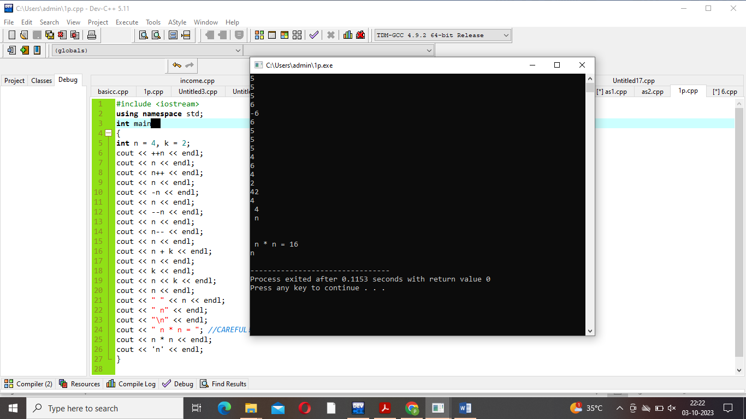

1. What is the output of the program below?

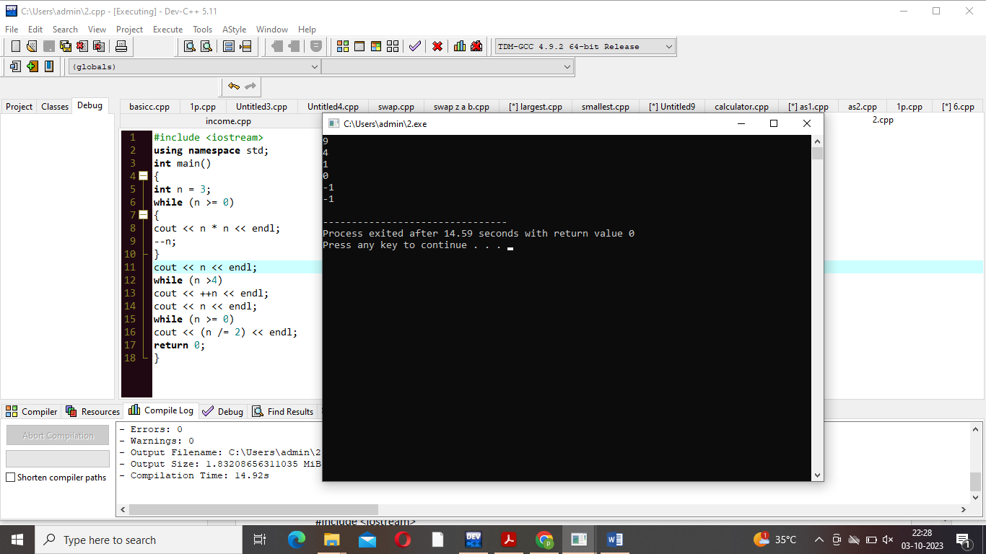3. What is the output of the program below?

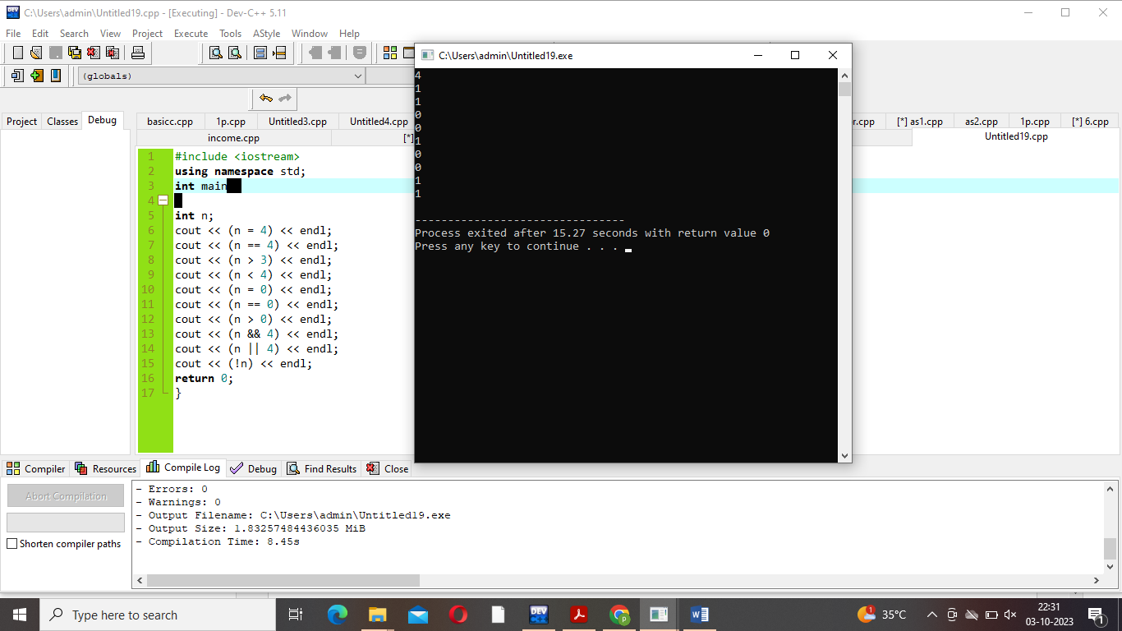4. What is the output of the following program?

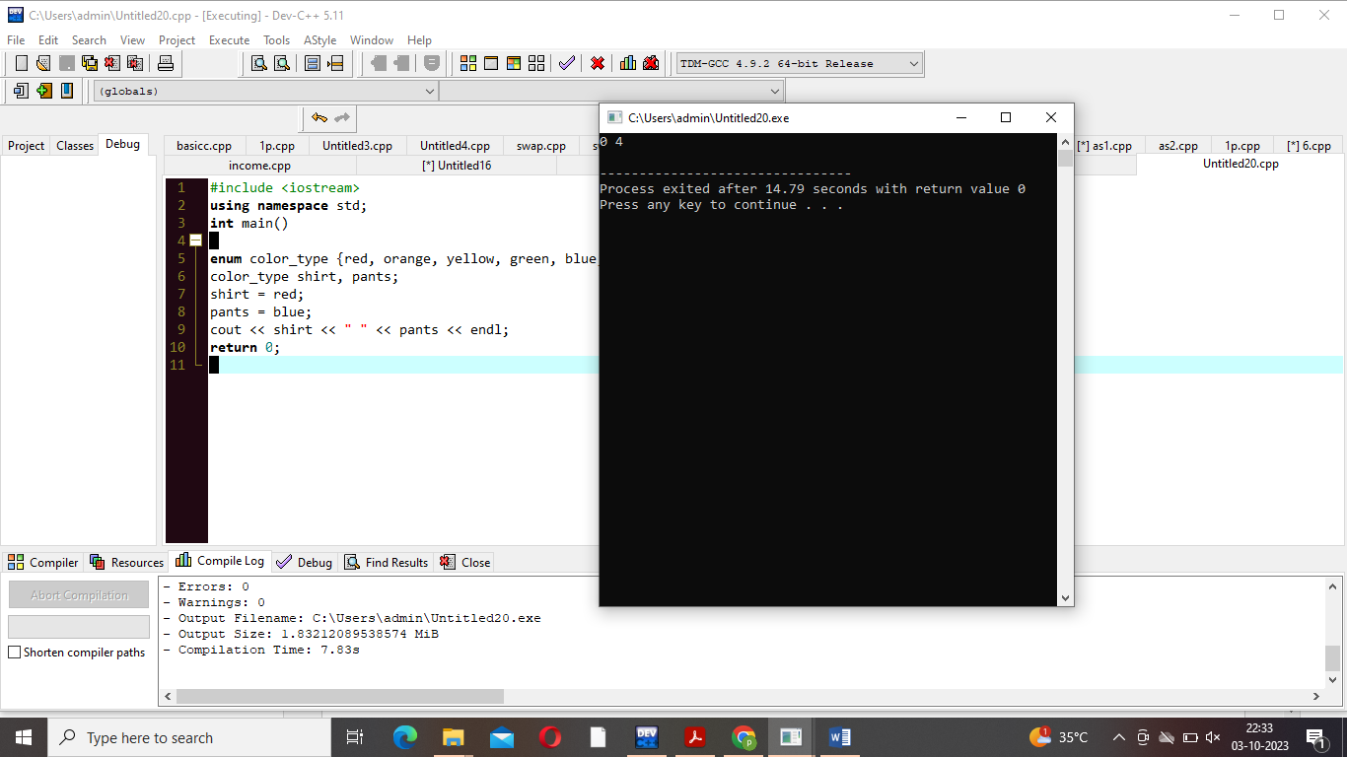5. What is the output when the following code fragment is executed?

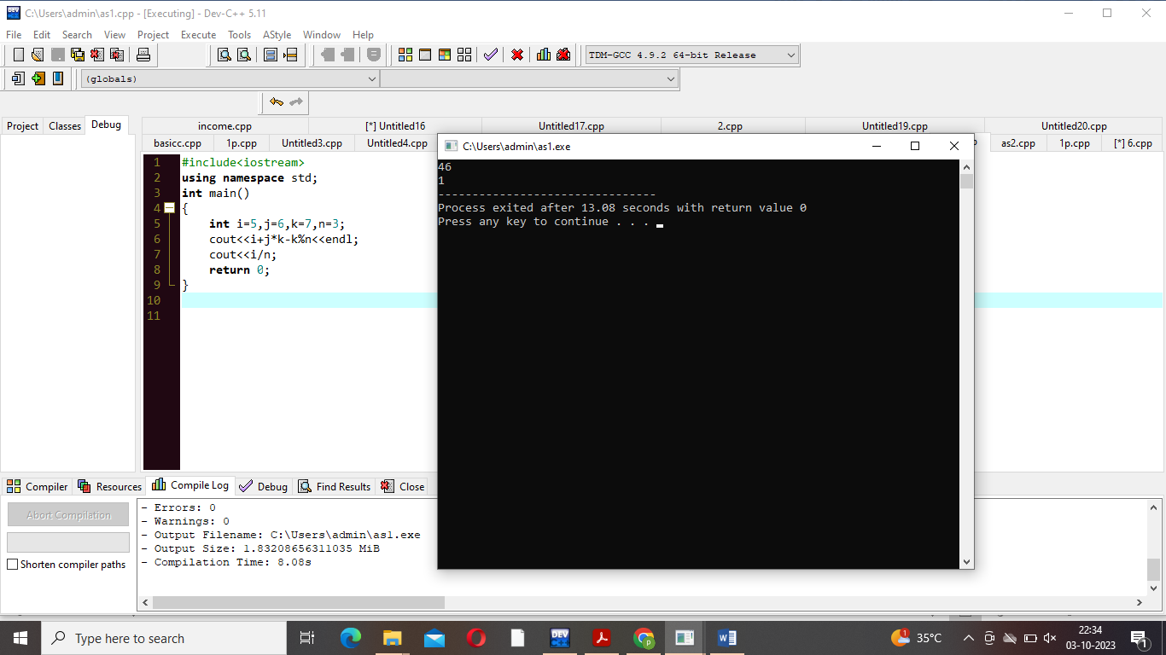6. What is the output when the following code fragment is executed?

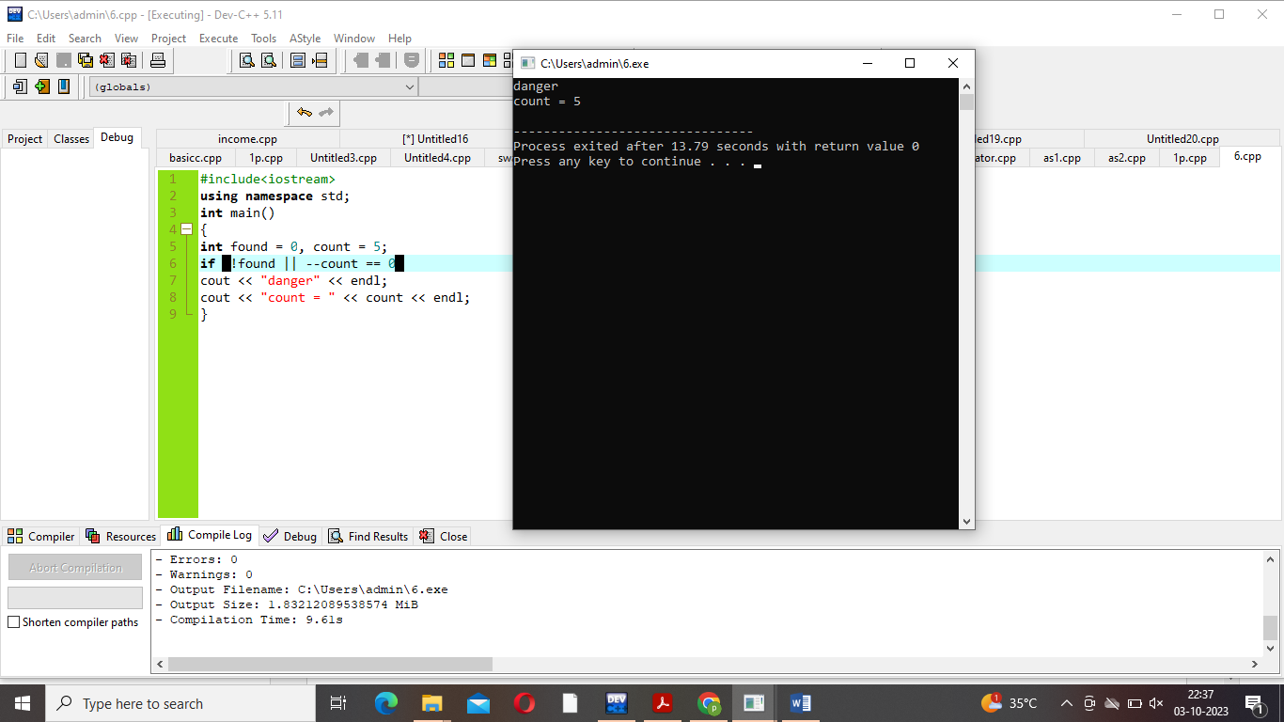7. The loop shown below has been written by an inexperienced C++ programmer. The behavior of

the loop is not correctly represented by the formatting.

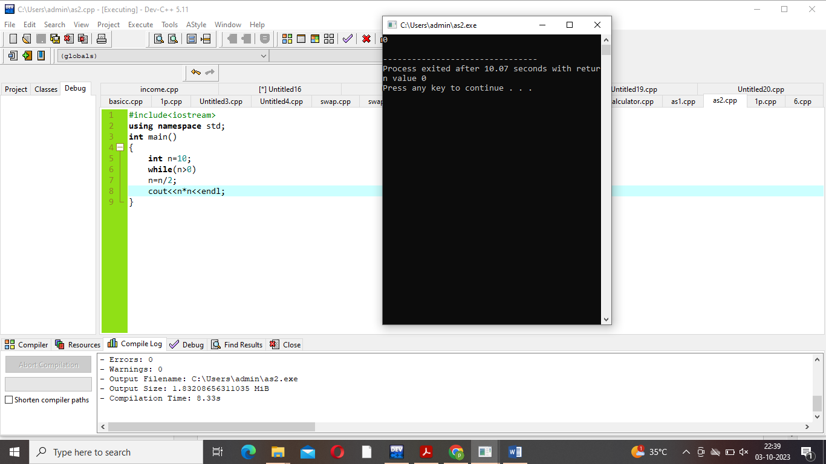8. Remove all the unnecessary tests from the nested conditional statement below.

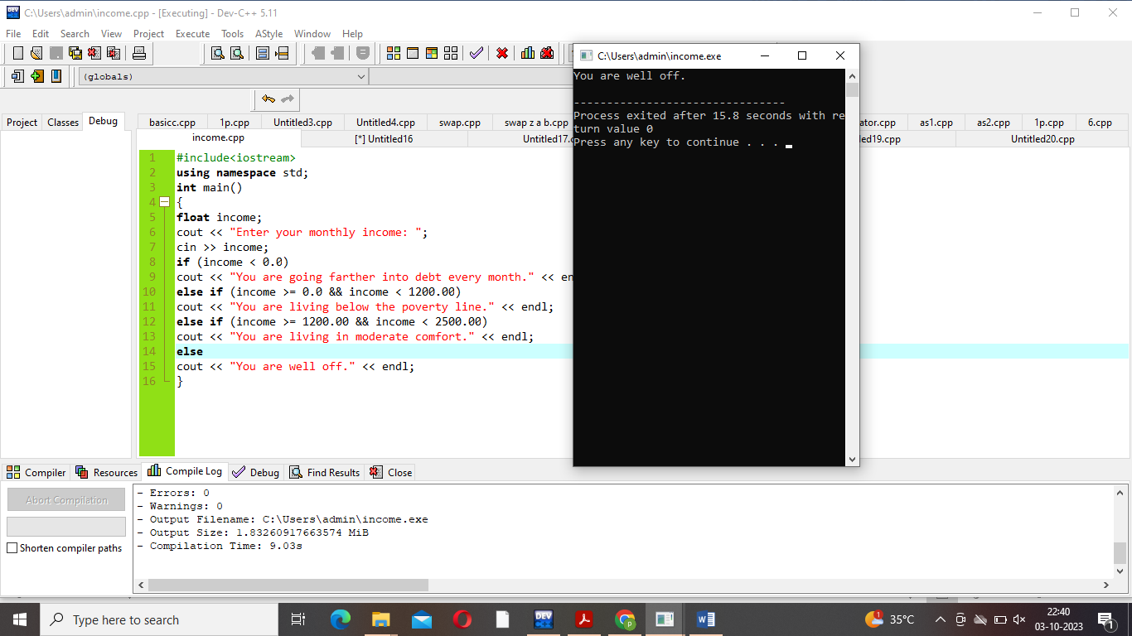9. Answer the questions below concerning the following fragment of code.

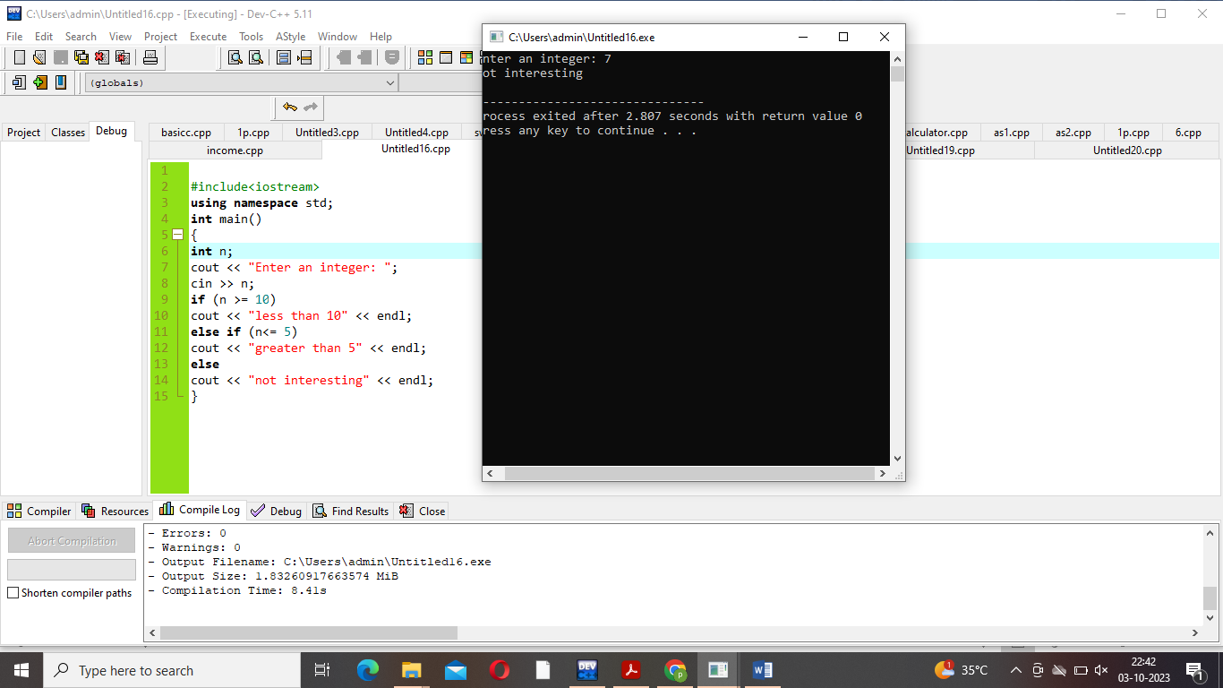10. Rewrite the following code fragment so that it uses a "do...while..." loop to accomplish the same

task.

